## FACULTY OF SCIENCE AND ENGINEERING

**SEMESTER 1, 2015**

**IAB330 - Mobile App Development Assignment 1: UI Design and High Fidelity Due Date: In-Class (Week 6)**

## Submission Method: Blackboard

## Weight: 30% Overall Grade

**Submission Coversheet Declaration**

You must sign below. By signing this form, you agree to the following:

* I/We declare that all of the work submitted for this assignment is our own original work except for material that is explicitly referenced and for which we have permission, or which is freely available (and also referenced).
* I/We agree that QUT may archive this assignment for an indefinite period of time, and use it in the future for educational purposes including, but not limited to: as an example of previous work; as the basis for assignments, lectures or tutorials; for comparison when scanning for plagiarism, etc.
* I/We agree to indemnify QUT and hold it blameless if copyright infringements are found in this work and the copyright owner takes action against QUT that is not covered by the normal terms of Educational Use.

The assignment should be attempted in a team of 2-3 students, and it is highly recommended that each team has the device you are developing for. Individual submission or a group of more than 3 is strongly discouraged. Consult with your tutor and unit coordinator if you have any issues.

|  |  |  |
| --- | --- | --- |
| **Team Member Details** | | |
| **Student Number** | **Student Name** | **Signature** |
| N8436801 | TszChung WU |  |
| N8667501 | Yun-Jung AN |  |
| N9197141 | Desheng LIU |  |
| N9231081 | PoShing Chun |  |

**Part A: Review of Existing UI Design**

1. **Review 3 closely related mobile applications**

**ALDI**

ALDI Australia “ALDI Special Buys” is designed for ALDI’s customer to check the weekly special deals in ALDI.  “ALDI Special Buys” is available in Apple iOS App Store under lifestyle category and Google Android Play Store under shopping category.  Both iOS and Android version have similar layout design and same functionality.

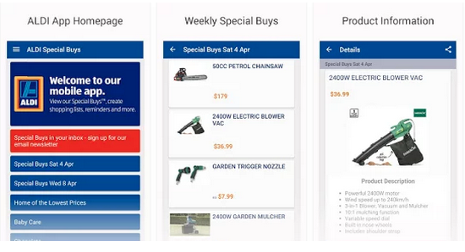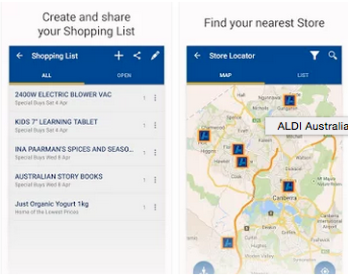

Source: ALDI Australia - Google Play Android Application Store

(<https://play.google.com/store/apps/details?id=de.apptiv.business.android.aldi_au>)

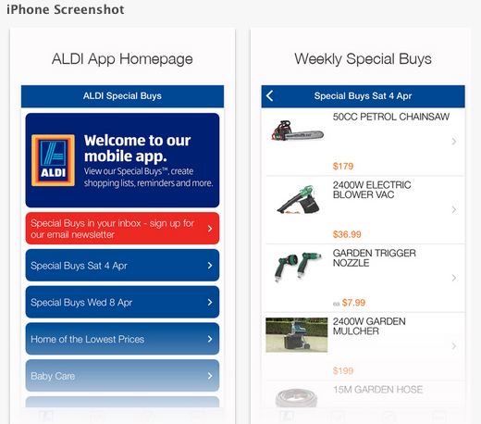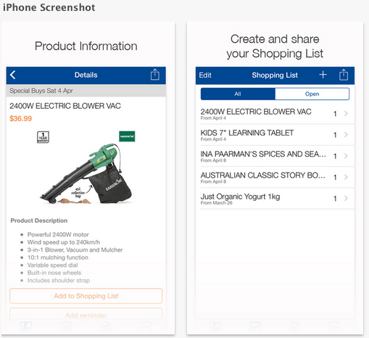

Source: ALDI Australia - Apple iTunes

(<https://itunes.apple.com/au/app/aldi-australia/id429158202?mt=8>)

There are a few feature functions for the user, which are “ALDI Special Buys”, “Shopping List” and “Store Locator”.   User can sign up for email Special Buys newsletter, view Special buys of the week and the lowest price of products in the “ALDI Special Buys” section, create a personal shopping list and share the list or specific item(s) by selected application in the “Shopping List” section and locate the user for the nearest ALDI store in the “Store Locator” section.  Besides, users are able to check the documentations from ALDI Australia and connect to their homepage and social media home page as well.

**ALDI – Positive impact**

ALDI Special Buys application is simple with 3 features, which can amplify the main use of this app to user. Besides, it has a personal shopping list, which can enhance the user experience.

The responsiveness of ALDI Special Buys is good, the application can give responses and show the next page immediately, but it takes a long time to fully load all items in the page.  “ALDI Special Buys” has a user friendly user-interface, user is able to use this application by one hand, and all the buttons are enough to use a thumb to control, user will not be touching the wrong button because of the size of button is too small.  User will be able to follow the icon and button to control the content without any difficulty, because the navigation button is always on the top left corner and using the same icon as all application does.

ALDI Special Buys has a reasonable navigation model, there is a menu button at the top left corner, once the user taps it, a navigation menu will be shown from the left of the screen.

**AIDI – Negative Impact**

ALDI Special Buys Application has a bad mobile context. It does not contain many contexts to attract people to use their application at all time. Because the main feature is letting ALDI’s customer to check the weekly special of ALDI.

ALDI Special Buys does not include online shopping feature, it only allows user to check online weekly special deals and create personal shopping list.

## Coles

Coles App is designed for Coles’ customer to check weekly special deals, locate product items in-store, check recipes, connects to flybuy account and more.  Coles App is available in Apple iOS App Store under food and drink category and Google Android Play Store under shopping category.  Both iOS and Android version have similar layout design and same functionality.

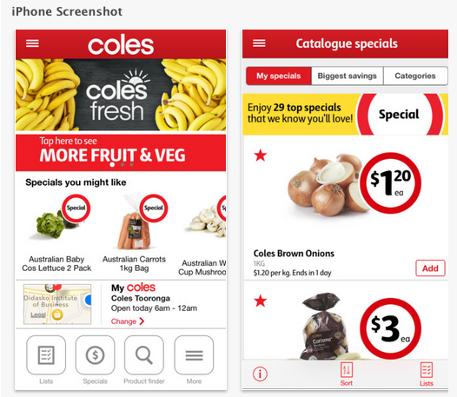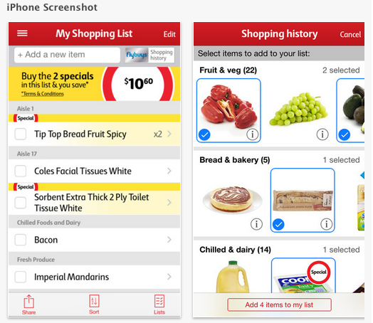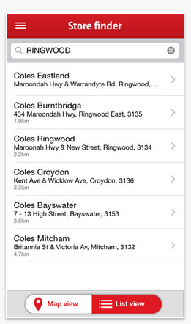

Source: Apple iOS App Store - (<https://itunes.apple.com/au/app/coles/id529118855?mt=8>)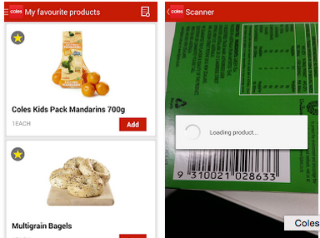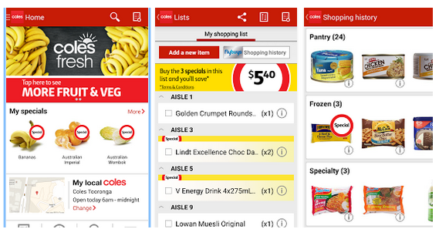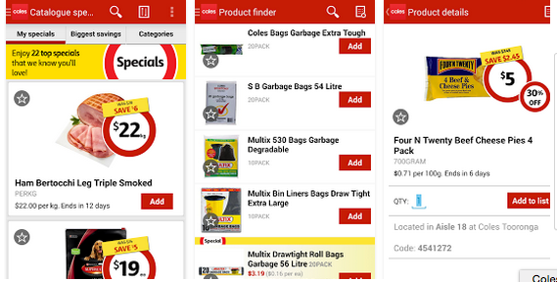

Source - Google Android Play Store (<https://play.google.com/store/apps/details?id=com.coles.android.shopmate>)

**Coles – Positive Impact**

Coles App has 3 main features, which are user-friendly and delight to use.  And Coles App has a personal shopping list, which optionally linked to personal flybuys account, weekly special deals, which also optionally linked to personal flybuys account and able to group by categories and product finders, which will provide product information, in-store locator to your nearest coles supermarket and nutritional information as well. These have clearly shown what they want to do with this application.

The user can use this application not only when they are boring, but also make good use of this application when they are in-store. By using the feature of scanner, customers are able to locate the product in-store.

The Coles App has a high responsiveness, once the user touches a button, the application can give a response immediately without any hesitation.  The button design and the use of icon also easy to read and big enough for all age-range of user.

**Coles – Negative Impact**

Coles did not use all advantages they have in their Coles App in the user perspective.  The user layout has too many information.

## IGA

## IGA Australia is designed by Independent Grocers of Australia(IGA) for their customer to update the weekly special deal, locate the nearest store, look for recipes and more.  IGA Australia is only available is Apple iOS App Store under food and drink category.

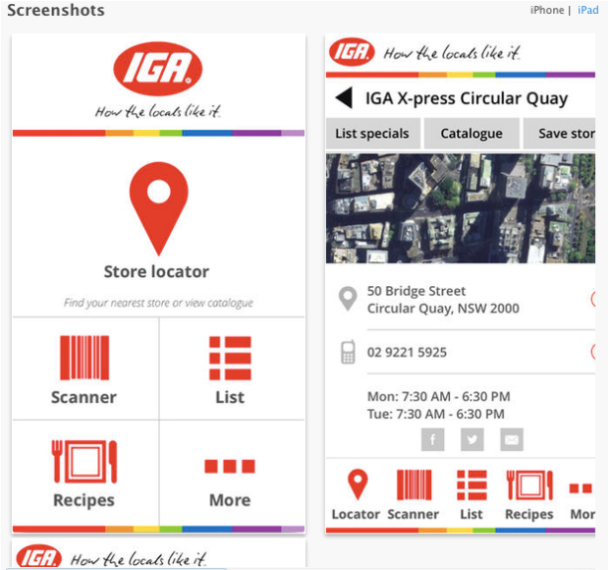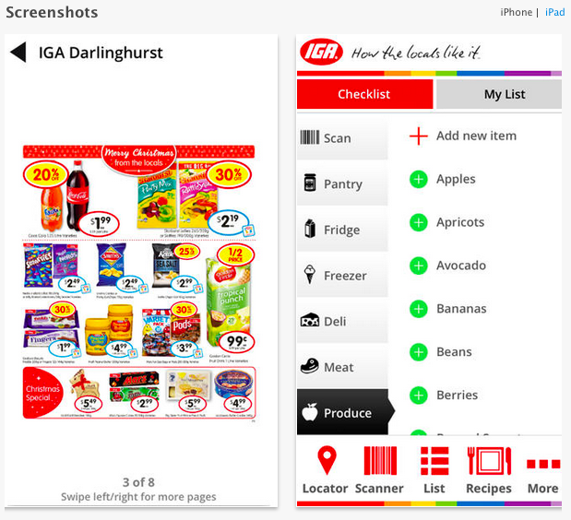

**IGA - Positive Aspect**

IGA Australia has a clear structure of menu.  We can know that IGA would like to bring customer to IGA by putting the store locator in the middle with the biggest icon button.  Besides, it has divided into 3 section in store locator, customers are able to search IGA store by the nearest location, manual search location and pre-selected location. In scanner page, an easy instruction tip is printed under the top logo bar for the user, which is very easy to understand.

In the list page, it is a personal shopping list, with check list function and my list function.

**IGA - Negative Aspect**

Since the customer hovered the camera over the barcode, the pop message will show to ask to put item into list, but not allow customer to have more options, such as, price check.

In the list page, it is a personal shopping list, with check list function and my list function, which is two check-list pages with similar functionality. And, in the list page check list function, there is a product category for customer, but unfortunately, the layout is too small, and unable to shown all the information, such as, product name, to the customer.

**5 Guidelines for our application design:**

**1.Direct Feedback Given**

Vibration can be customized to alert users when they finish an action or reach an error, for instance, alert the user to the end of a long-running event such as a download completing (peddle, n.d.).

For example, a vibration will be made after the user had put a product into the basket or scanned an item and alert will be shown if a confirmation will be asked before the user is confirm to check out.

**2.Implement navigation in a way that supports the structure**

User should know where they are in the app, how to get to their next destination and importantly the navigation in the application is logical, predictable and easy to follow (Apple, n.d.).

In our application, the current position can be shown at the top of the application with back button and other functional button such as edit, cancel, done.

**3.Consistent Layout**

Helping user to keep focus on the primary content of the application, do not change the focus when the screen is changed because users will lose control over the application (Apple, n.d.)

Always put the navigation bar at the top of our application and put the main information in the middle. Do not put many information in one page so that users can easily find the focus of the page.

**4.Good color contrast and font style**

Make sure there is enough contrasts between phone elements such as bar-button, titles and background to prevent users cannot see the buttons (Apple, n.d.). Assign meaning to colors and use color to communicate, for instance using a color to represent a brand (Apple, n.d.). Prevent to use different fonts throughout the app because it will make the app seem fragmented (Apple, n.d.).

We can use a color to represent our application brand Woolworths and one single font style to keep the consistency.

**5. Pictures are faster than words**

Images are better to explain ideas which can also draw people’s attention easily (Android Developers, n.d.). People can understand a situation or an action much more effectively and can imagine the result (Android Developers, n.d.).

In our application, we should use pictures with words to indicate each function so that users can expect what they want easily and using pictures to explain content details which is effcient than a sentence.

**Part B: High Fidelity Prototype**

**1. Describe your app in ‘executive summary’ style**

Our team name is EasyTechy, we are doing the Woolworths project CheckOutLess and our application name is EasyCheckout. The main features are able users to connect the application with an external hardward e-basket and directly use camera to scan product. The e-basket has a built-in scanner which can scan product immediately when users put items into it. The camera scanner can scan the item by aimming the barcade at the product and send the item details to the cart page as well as the e-basket. Also, this application has cart features which can help user to keep tracking their cart list and edit what they want. Login and authentication and personal profile is crucial to our application because it stores users’ information securely. Importantly, this application provides e-recepit so that user can check their every transaction in this application. When user about to go to shopping, they can use the buy-list feature to create a buy-list so that they dont need to remember everything. This application has a minor feature which is map functions, it can help user to locate WoolWorths store and a particular product inside a store.

Our primary intended users would be someone need to buy merchandise at a large amount so that they dont need to waste unneccessery time to stand on check out queue and they can use our application to tracking their buy-list. Moreover, someone buying less than 3 items would be our minory inteneded user, they can just pick up their product, scan, pay and go which is not time-consuming.

**2. Discuss the use case scenarios**

Screnario 1: Shopping in Woolworths

Pre-condition: user have to login

Primary actor: Jack

Basic flow:

1. Jack can create a buy-list in the application before shopping.
2. Jack uses app to connect a Woolworths E-basket
3. Jack picks up a shopping E-basket and he start shopping.
4. Jack picks up an item from a shopping shelf.
5. Jack put an item to the shopping E-basket and scan it.
6. The item will be shown up automatically on the application and ready to check out.

Scenario 2: Buying a few number of items

Precondition: Users have to login in

Primary actor: jack

Basic flow:

1. Jack walks into Wool-Worths
2. Jack picks up a bottle of water from the shopping shelf.
3. Jack scans the water and check out.

Scenario 3: Check out

Pre-condition: user have to login and basket not empty.

Primary actor: Jack

Basic flow:

1. Jack presses check out button.
2. Jack needs to confirm the transaction.
3. IOS or Android native payment page will pop up.
4. Jack confirms the payment.
5. E-receipt will be shown up.

**3. Describe your information architecture**

The main page of our application is the homepage and it acts like a jump-point for other pages. However, some pages are linked together to create a work flow. Cart, scanner, e-basket connect and e-receipt pages require user to login to continue the services, so the application will connect a database, if user login is not successul, they will return back to login/signup page. In e-basket connect page, it will connect an external hareware by Bluetooth or scanning QR code, after that it will send the product code to the cart page as well as scanner page does. In cart page, it converts the product code to a detail item information by connecting to a database and save the list in the application storage temporarily and ready for user to checkout. In checkout page, it will automatically use the iOS or Andriod native payment. To-buy and Map page are not required user to login. To-buy page is like a note to allow user save what they want to buy in the application storage and map page will connect to google service to provide the locations of Woolworths store. Genrally, all pages provide a back button to return to the previous page.

Please see the attach file – IAB330 Information architecture.pdf

**4. Static prototype of the entire app’s interaction flow**

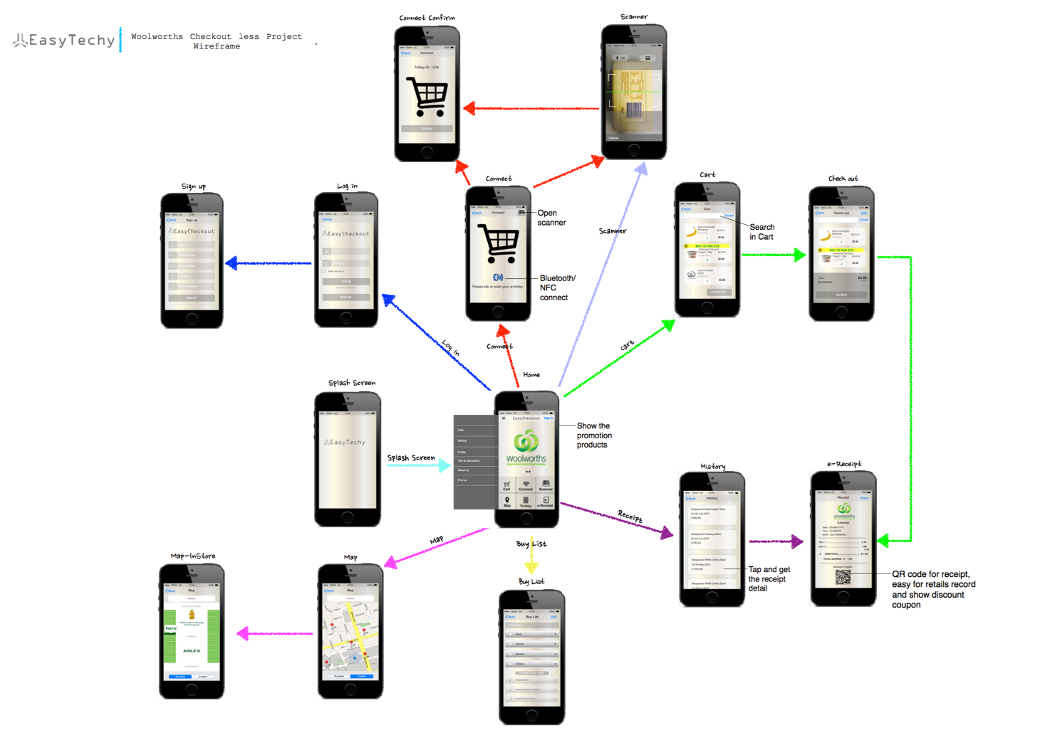

Please see the attach file – IAB330 StoryBoard.pdf

**5. Interactive and functional Prototypes**

Please go to – <http://we0nav.axshare.com>

And see the readme.txt.

**Refernece List:**

Android Developers (n.d.). Android Design Principles. Retrieved 24 August, 2015

from <http://developer.android.com/design/get-started/principles.html>

Apple (n.d.). iOS Human Interface Guidelines, Navigation. Retrieved 23 August, 2015

from <https://developer.apple.com/library/ios/documentation/UserExperience/Conceptual/MobileHIG/index.html#//apple_ref/doc/uid/TP40006556-CH66-SW1>

Pebble (n.d.). RECOMMENDED GUIDELINES AND PATTERNS. Retrieved 23 August,

2015 from <http://developer.getpebble.com/guides/design-and-interaction/recommended/>